SIMATS ENGINEERING
ASSESSMENT TOOL 1

COURSE NAME: Database Management Systems
COURSE CODE: CSA0504

COURSE OUTCOME COVERED

CO1: Analyze DBMS architecture, different data models, schema types, and design ER/EER diagrams, relational schemas for case-based scenarios by identifying entities and relationships. (BL1, BL2)

Activity Tool : Short Answer Text(High)
Assessment Tool Weightage: 40%

QUESTIONS
Q. No | Question | Bloom's Level
1 | Explain schema and instance with examples. Distinguish between logical schema, physical schema, and view schema. | BL1 – Remember
2 | Identify the entities, attributes, and relationships for a Bank Management System and construct its ER diagram. | BL2 – Understand
3 | Explain the Extended ER (EER) model. Describe the concepts of generalization, specialization, and aggregation. | BL2 – Understand
4 | Design an EER diagram for a Hospital Management System incorporating inheritance and weak entities. | BL2 – Understand
5 | Explain the role of a DBA (Database Administrator) and the responsibilities associated with the position. | BL1 – Remember

Code of Conduct:

I DARSHINIE KARANI V M(192520033) (Name / Reg No) certify that this submission is my original work and that I have adhered to the guidelines specified for this assessment.
I understand that any violation of academic integrity rules will result in disciplinary action.

Signature of the student:

RUBRICS FOR CALCULATION:

Criteria | Weightage | Level 4 (Exemplary) | Level 3 (Proficient) | Level 2 (Developing) | Level 1 (Beginning)
Concept Identification | 30% | Demonstrates  clear and  complete  understanding of  the concept | Good  understanding  with minor  gaps | Basic  understanding  with some  misconceptions | Poor or  incorrect  understandin  g
Linkages | 25% | Completely  correct answer  with no errors | Mostly correct  with minor  errors | Partially correct  with noticeable  errors | Incorrect or  irrelevant  answer
Organization | 20% | Correctly applies  concepts to solve  the  question/problem | Applies  concepts with  minor  mistakes | Limited or  partially correct  application | No or  incorrect  application
Integration of Literature | 15% | Covers all  required parts of  the question | Covers most  parts with  minor  omissions | Covers only  some parts | Incomplete  or missing  response
Clarity | 10% | Clear, concise,  and well-  organized answer | Understandabl  e with minor  issues | Somewhat  unclear or poorly  structured | Difficult to  understand

SHORT ANSWERS

1.
Schema:
- A schema is the overall design or blueprint of a database. It defines the structure of the database, including tables, attributes, data types, relationships, and constraints. A schema is defined during database design and changes very rarely.
- Schema is a structure of table or database.

Instance:

An instance is the actual data stored in the database at a particular point in time. Unlike the schema, the instance changes frequently as data is inserted, updated, or deleted.
- Instance is a variable or actual data is stored in a database.

Logical Schema | Physical Schema | View Schema
Describes the logical structure of the database. | Describes how data is physically stored in memory or disk. | Describes only the part of the database visible to a specific user.
Contains tables, attributes, relationships, and constraints. | Contains storage details such as files, indexes, and access methods. | Contains virtual tables (views) created from one or more base tables.
Used by database designers and developers. | Used by the Database Administrator (DBA). | Used by end users and application programs.
Independent of physical storage. | Depends on storage devices and organization. | Provides security by hiding unnecessary data.
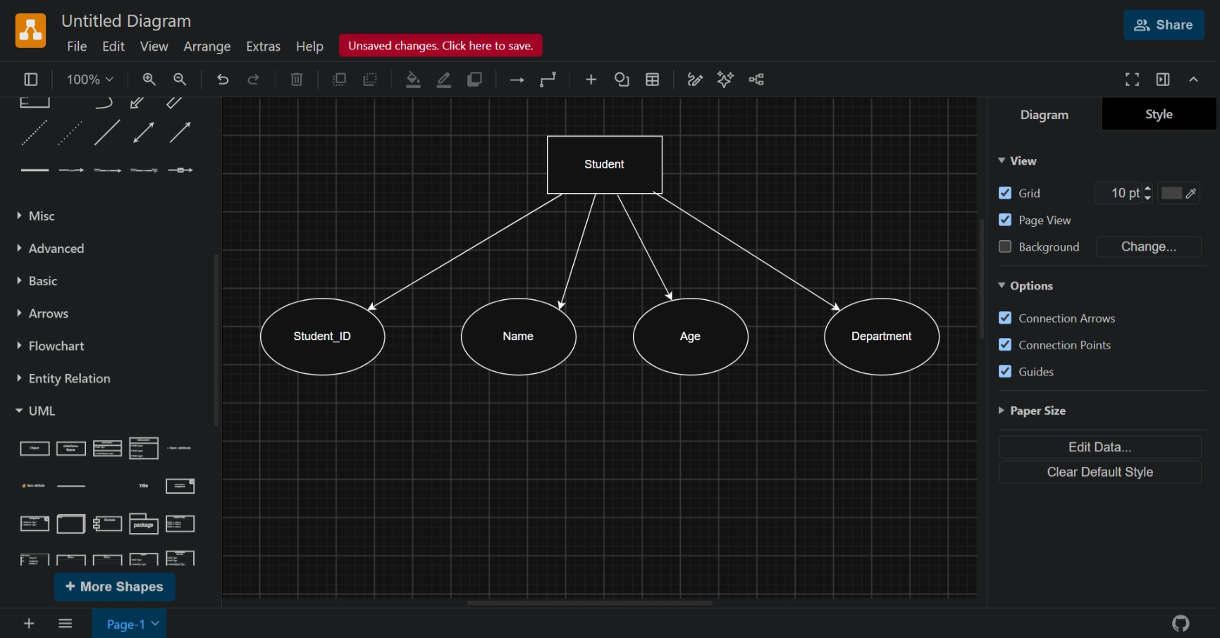
2.
Bank Management System:
A Bank Management System stores and manages information about customers, accounts, branches, employees, and loans. An ER diagram helps represent these entities and their relationships.

Entities and Attributes

Customer is an Entity
  - Customer_ID (Primary Key), Name, Address, Phone_Number, Email is an attribute

Account is an Entity
  - Account_No (Primary Key), Account_Type, Balance, Opening_Date is an attribute

Branch is an Entity
  - Branch_ID (Primary Key), Branch_Name, Location is an attribute

Employee is an Entity
  - Employee_ID (Primary Key), Name, Designation, Salary is an attribute

Loan is an Entity
  - Loan_ID (Primary Key), Loan_Type, Loan_Amount, Interest_Rate is an attribute

Relationships
- Customer → Owns → Account
  - One customer can own one or more accounts.
  - One account belongs to one customer.
- Account → Maintained by → Branch
  - A branch maintains many accounts.
  - Each account belongs to one branch.
- Branch → Employs → Employee
  - One branch employs many employees.
  - Each employee works in one branch.
- Customer → Takes → Loan
  - A customer can take multiple loans.
  - Each loan belongs to one customer.
- Branch → Sanctions → Loan
  - One branch can sanction many loans.
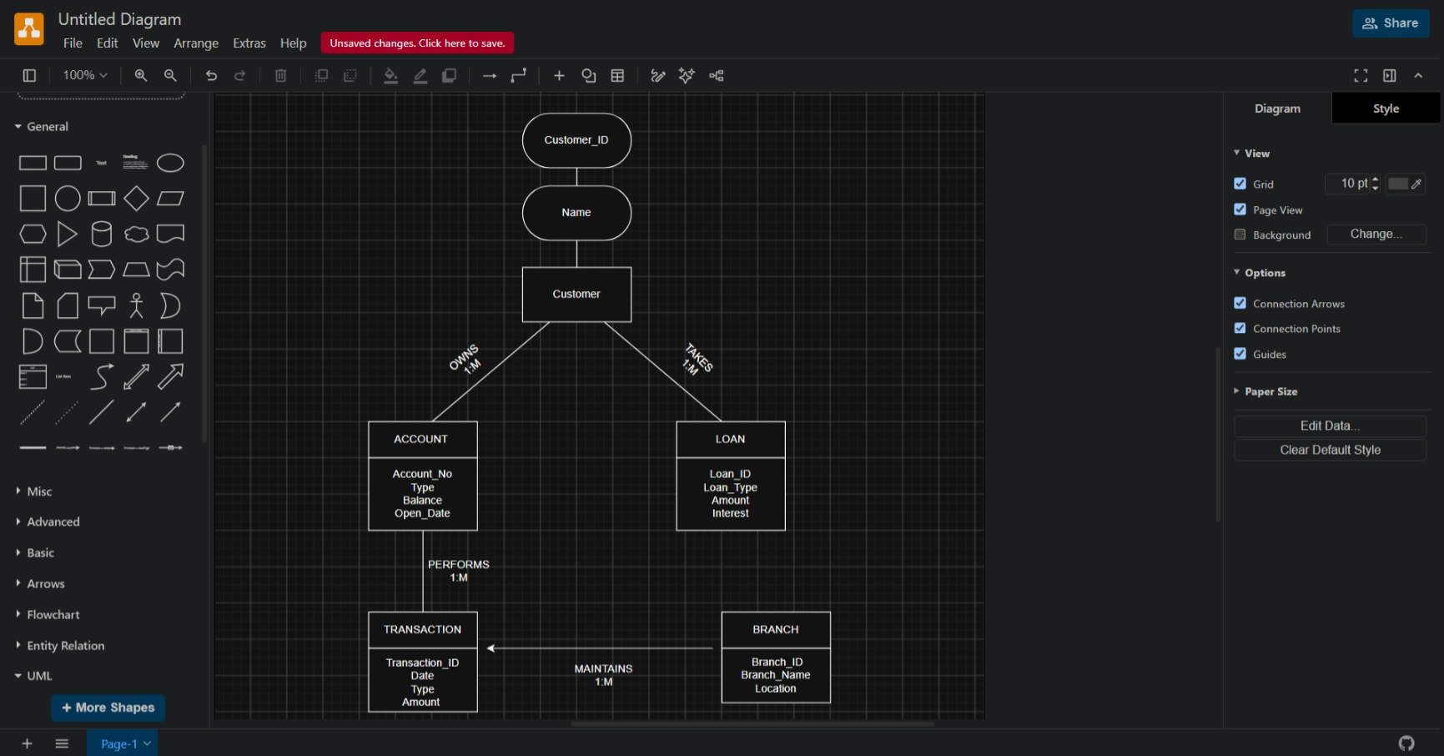
3.
Extended Entity Relationship (EER) Model:
The Extended Entity Relationship (EER) model is an advanced version of the Entity Relationship (ER) model. It provides additional features to represent complex real-world applications more effectively. The EER model supports concepts such as inheritance, generalization, specialization, aggregation, and categories (union types), making database design more flexible and accurate.

Features of the EER Model:
- Supports inheritance between entities.
- Represents superclass and subclass relationships.
- Reduces data redundancy.
- Models complex business rules effectively.
- Improves database organization and design.

Generalization
Generalization is the process of combining two or more lower-level entities (subclasses) into a single higher-level entity (superclass) based on their common attributes.
Example: Here, Savings Account and Current Account have common properties such as Account Number and Balance, so they are generalized into the superclass Account.
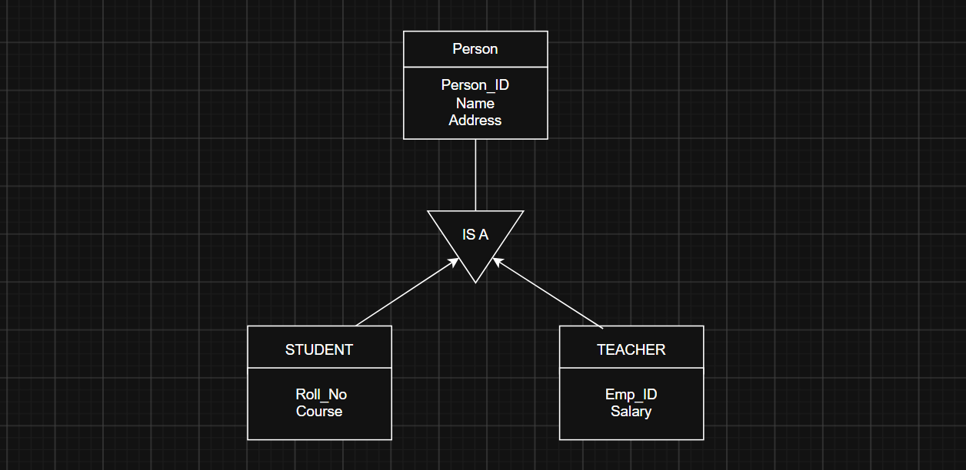

Specialization
Specialization is the process of dividing a higher-level entity (superclass) into lower-level entities (subclasses) based on specific characteristics.
Example: Here, Employee is the superclass, while Manager and Clerk are specialized subclasses with additional attributes.
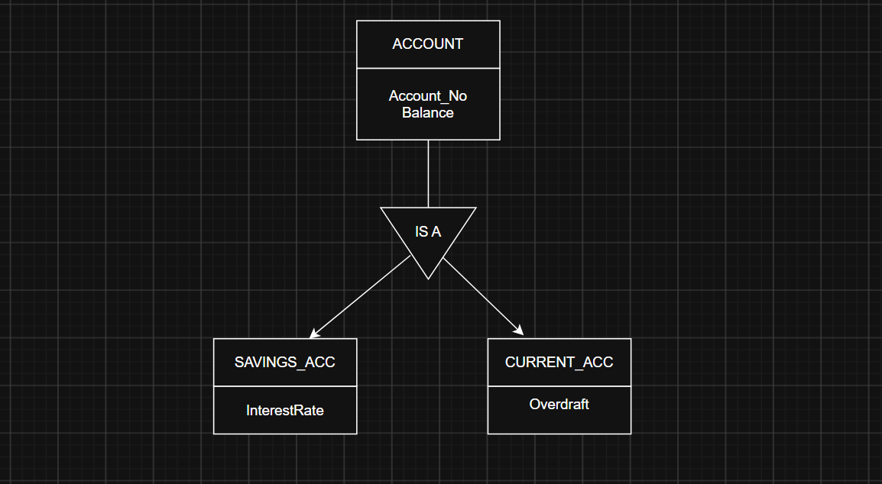

Aggregation
Aggregation is a process in which a relationship between entities is treated as a higher-level entity so that it can participate in another relationship.

Example: Here, Works_On is considered as an entity so that the Department can manage the relationship between Employee and Project.
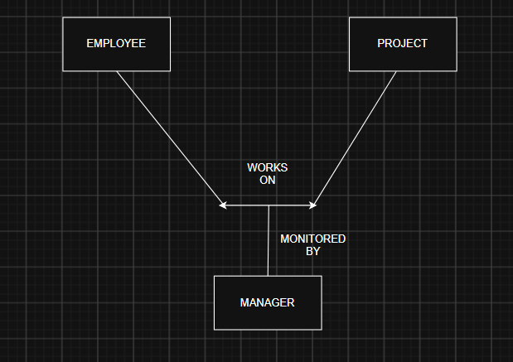

4.
Hospital Management System – EER Model:
A Hospital Management System stores information about doctors, patients, departments, appointments, and medical records. In the EER model, inheritance is represented using a superclass and subclasses, while a weak entity depends on another entity for its existence.

Entities

Superclass
- Person
  - Person_ID (PK)
  - Name
  - Age
  - Gender
  - Phone_No

Subclasses (Inheritance)
- Doctor
  - Doctor_ID
  - Specialization
  - Qualification
- Patient
  - Patient_ID
  - Blood_Group
  - Disease

Other Strong Entities
- Department
  - Department_ID (PK)
  - Department_Name
- Appointment
  - Appointment_ID (PK)
  - Date
  - Time

Weak Entity
- Medical_Record
  - Record_No (Partial Key)
  - Diagnosis
  - Prescription
The Medical_Record is a weak entity because it cannot exist without a Patient.

Relationships
- Person is specialized into Doctor and Patient (Inheritance).
- Doctor works in a Department.
- Doctor treats Patient.
- Patient books an Appointment.
- Patient has a Medical_Record (Weak Entity).
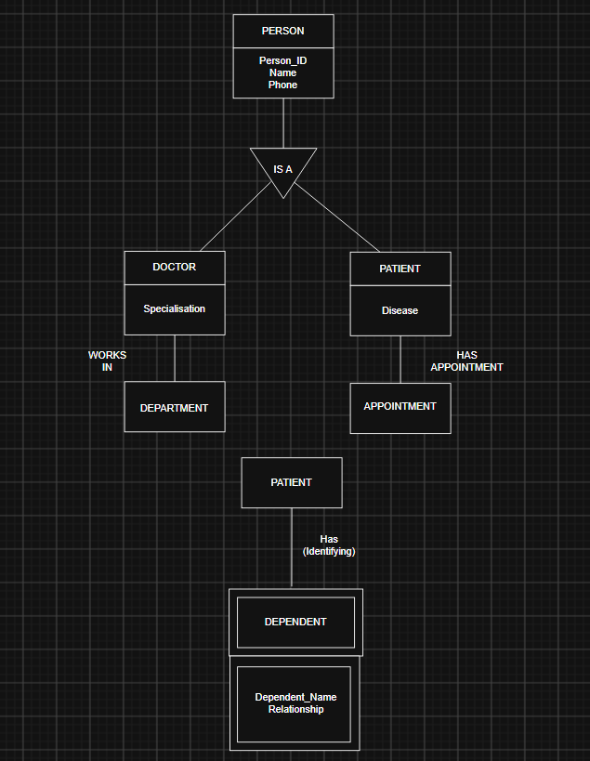5.
A Database Administrator (DBA) is a person who manages and maintains the database of an organization. The DBA ensures that the database is secure, reliable, and performs efficiently. They are responsible for protecting data, controlling user access, and ensuring that the database is always available when needed.

Responsibilities of a DBA

1. Database Installation and Configuration
The DBA installs database software and configures it according to the organization's requirements.

2. Database Design and Maintenance
The DBA creates and maintains database structures such as tables, indexes, and relationships to ensure efficient data storage.

3. Security Management

The DBA provides user authentication, assigns permissions, and protects the database from unauthorized access.

4. Backup and Recovery
The DBA performs regular backups and restores data in case of system failure, data loss, or disasters.

5. Performance Monitoring
The DBA monitors database performance, identifies bottlenecks, and optimizes queries for faster execution.

6. Data Integrity
The DBA ensures that the data stored in the database is accurate, consistent, and free from duplication.

7. Storage Management
The DBA manages disk space, storage allocation, and database files to ensure efficient use of resources.

8. Troubleshooting
The DBA identifies and resolves database errors, software issues, and system failures to maintain smooth operation.

9. Software Upgrades
The DBA installs updates, patches, and new versions of the database software to improve performance and security.

10. User Support
The DBA assists users by resolving database-related issues and providing technical support when required.
Conclusion
A Database Administrator (DBA) plays an important role in managing, securing, and maintaining a database. By handling tasks such as backup, recovery, security, performance optimization, and user management, the DBA ensures that the database remains efficient, reliable, and available for the organization.

